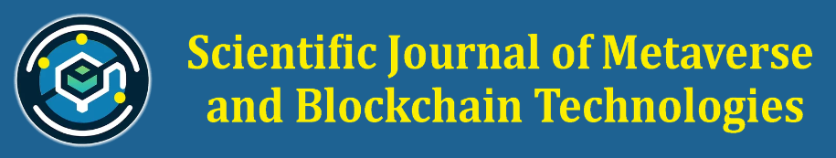**Fee Waiver Request Form**

**Applicant Details:**

1. **Full Name of the Corresponding Author:**
2. **Email Address:**
3. **Institutional Affiliation:**
4. **Country of Residence:**
5. **Co-Authors (if applicable):**

**Manuscript Details:**

1. **Manuscript ID No.:**
2. **Manuscript Title:**
3. **Abstract / Brief Summary of the Manuscript:**
4. **Submission Date:**

**Fee Waiver Request Information:**

1. **Reason for Requesting the Fee Waiver (please specify financial constraints, status as an early career researcher, employment status, annual income etc.)**
2. **Are there any institutional or external funding sources available to cover the APC?**
   * Yes
   * No
   * If Yes, please provide details:
3. **How does your research contribute to the fields of metaverse technology, Non-Fungible Tokens (NFTs), and blockchain technology?**

**Declaration and Consent:**

(Tick the boxes)

I hereby declare that the information provided in this form is accurate and complete to the best of my knowledge.

I understand that this request will be assessed based on SJMBT’s Fee Waiver Program criteria and that submission of this form does not guarantee a waiver.

I consent to SJMBT collecting and using my personal data provided in this form for the purpose of evaluating my fee waiver request.

The Proof of Financial hardship is uploaded along with this form. If any discrepancy is found, my application shall be rejected.

**Name of Applicant along with Contact Details:**

**Date:**